# **Project Bookworm**

# **A Level Computer Science Project Development Writeup and Documentation**

# **Project Bookworm**

**Project Bookworm** **1**

**A Level Computer Science Project Development Writeup and Documentation** **1**

**Project Bookworm** **2**

**AQA A Level Computer Science Project Write Up** **6**

Analysis 6

Introduction 6

Description of current system 6

(Fig 1.) General Details for a School 7

Fig 1. Screenshot of current system spreadsheet example for a school. 8

Data collection and research: 8

Identification of End Users: 8

Questionnaire: 9

Fig 2. Question about respondents interest in a new system. 9

Fig 3. Questions about desired features in the new system. 10

Fig 4. Questions about a report creation feature. 10

Fig 5. Questions regarding reports being generated by the system. 11

Results: 11

Experience of using the current system: 11

Fig 6. Results of the question regarding the experience of using the current system. 11

Thoughts regarding the speed of using the current system: 12

Fig 7. Results of the question regarding the speed of using the current system. 12

Proneness of the current system to human error: 12

Fig 8. Results of the question regarding how prone the current system is to human error. 12

Main feature requests: 13

Fig 9. Results of the question regarding features wanted by the users. 13

Reports Requested: 14

Fig 10. Results of the question regarding the reports that the system should create. 14

Fig 11. Open responses to the question regarding the reports that the system should create. 15

Fig 12. Responses to the open question regarding what format the reports should be in. 16

Evaluation: 16

Identification of User Needs 17

Acceptable Limitations: 17

Data sources and destinations 17

Data Volumes 17

Objectives for Proposed System: 19

Key Objectives: 19

Additional Objectives: 19

Analysis data dictionary and ERD 20

Fig 13. Database ERD 20

Data Dictionary 21

Books 21

changed_books 23

loans 24

logins 24

schools 25

Realistic appraisal of the feasibility of potential solutions: 26

Justification of chosen solution: 27

Design 27

Overall System Design 28

Fig 14. System Design Flowchart. 29

Description of modular structure of system 30

Modules: 30

Objects: 30

Function Modules 33

Modular Design 35

Definition of data requirements 36

Identification of appropriate storage media 36

Entity relationship diagram(Normalised) 36

Entity Relationship Diagram: 36

Fig 15. Program Entity Relationship Diagram. 37

User interface design (HC) 37

Login Screen 37

Fig 16. Login screen. 38

Homepage 38

Fig 17. Program Homepage. 39

Book Details 39

Fig 18. Entry form for single ISBN. 39

Fig 19. Book Details form 40

School Details 41

Fig 20. Menu for selecting the a school to show the details of. 41

Fig 21. Empty School Details form for adding a new school. 42

Fig 22. School Details form in view mode with no save button for any changes. 43

Fig 23. School Details form filled out with values from the database. 44

Sign Out Books 45

Fig 24. Menu for initialising the loaning and return process. 45

Fig 25. Empty Loaning/Returning form 46

Settings 46

Fig 26. Settings menu as seen when signed in as an admin. 47

Hardware specification 48

Input Devices 48

Output Devices 48

Storage devices 48

Processor and Memory requirements 48

Table: 48

Testing 49

Description of measures planned for security and integrity of data and system security 49

Overall test strategy 49

Testing Details 50

Fig 27. Table of Tests conducted. 50

System Maintenance 51

System Overview 51

Sampled Detailed Algorithms 52

Guide 52

Accessing the System via the Login Menu: 53

Fig 28. Login menu with references for user guide. 53

Homepage: 53

Fig 29. Homepage screenshot with references for user guide. 54

Viewing and Editing Book Details: 54

Fig 30. ISBN Entry form. 55

Fig 31. Book Details form. 56

Loan Books out to a School 57

Fig 32. Loaning starting menu. 57

Fig 33. Multiple Books entry form. 58

Return Books from a School 59

Generating Reports: 59

Fig 34. Reports Wizard 60

Fig 35. Example of a generated Report. 61

Adding, Editing and Viewing School Details. 61

Fig 36. School Details form. 62

Fig 37 a. Viewing School Details 63

Fig 37 b. Editing School Details 64

Fig 37 c. Adding a new school. 65

Settings: 65

Changing the program theme: 66

Changing the Database Location: 66

Changing the Assets and Temporary Files Location: 66

Adding a New User: 67

Fig 39. Add New User menu 67

Evaluation 68

Key Objectives: 68

Additional Objectives: 70

Program Code 72

# 

# **AQA A Level Computer Science Project Write Up**

## **Analysis**

### **Introduction**

Hampshire County Council's School Library Service (SLS) loans books to over 400 schools in Hampshire and has four centres located in Basingstoke, Farnborough, Fareham and the New Forest. The SLS provides various services as well, including loaning books and e-resources, training and advisory/support services. The school's exchange books by visiting a centre or receiving delivery via a small fleet of vans. The standard allocation of books is three per pupil at primary level and two per pupil at secondary with a maximum loan of two hundred books per exchange.

### **Description of current system**

Currently, the SLS only tracks the quantity of books at a given location using an Excel spreadsheet for each centre and one tab for each school. Each tab contains the following details about the school (see figure 1 below) as well as the details of each exchange including the number of books and the date. When a school visits a centre to exchange books, the library assistants at the centre physically count all of the books as they come in and go out and record this in the spreadsheet, which then calculates the total for each individual school.

The clients requirements were investigated by speaking with one of the library assistants as well as conducting a survey amongst the rest. I also went to a showcase day for library management systems aimed for internal use in a school library. These apply a similar principle to my project however they work on a larger scale in terms of volumes of users and books.

The main issue with the current system is that the library assistants have no way of knowing where books are located. Currently a school cannot request a list of books that they have since there is no tracking data available to look this up with so currently an accurate stock taking exercise be undertaken. Another issue is that one school is not supposed to have more than two copies of any book but this is difficult to manage since there is not a list of what books they have to check against.

#### **(Fig 1.) General Details for a School**

Each school currently has its own tab in the spreadsheet. At the top of each tab is a header containing the following information:

* School Name
* Head Teachers Name
* Address
* Contact Details
* The DfE Number (unique number assigned by the Department for Education to each school)
* Date of the Last Exchange
* Number of Pupils

Below these details, there is a table of the exchanges and details of them including:

* Date
* Comments/Notes
* Type of exchange
* Number of books returned
* Number of books issued

At the bottom of the sheet, is a tracking table for stock check visits including:

* Date
* Stock they should have
* Stock counted
* Total items lost
* Percentage of loan that has been lost

###### Fig 1. Screenshot of current system spreadsheet example for a school.Screenshot of a tab for a school

### **Data collection and research:**

#### **Identification of End Users:**

The users would be the librarians at the Hampshire School Library Service who could use it to manage the loans easier.

#### 

#### **Questionnaire:**

In order to gauge the needs of the users and therefore the requirements of the system, I created an online survey that could be passed around to the SLS library assistants to easily collect the data needed. I then used that data to form the Key Objectives and Additional Objectives that my system should meet.

In order to create the survey, I used a free online survey creator called Enalyzer

Questions about the current system:

###### Fig 2. Question about respondents interest in a new system.Current System Questions

###### Fig 3. Questions about desired features in the new system.Interest Question

###### Fig 4. Questions about a report creation feature.Desired Features Questions

###### Fig 5. Questions regarding reports being generated by the system.Report Creation Questions

##### **Results:**

###### **Experience of using the current system:**

###### Fig 6. Results of the question regarding the experience of using the current system.

This question asked about how the users found the experience of using the current system. All of the surveyees gave a response of adequate to excellent. This shows that the users are used to using the current system and that a change would possibly take a while to get used to or be initially rejected. This means the new system should be intuitive for the user, in order to have a smooth transition to the new software.

###### 

###### **Thoughts regarding the speed of using the current system:**

###### Fig 7. *Results of the question regarding the* speed *of using the current system.*

All those surveyed noted that the speed of the current system as being somewhere between 6 and 9 on a scale of 1-9 with 1 being “Very slow” and 9 being “Very fast”.

###### **Proneness of the current system to human error:**

###### Fig 8. Results of the question regarding how prone the current system is to human error.

This question asks the surveyees how much the current system for monitoring exchanges is prone to human error. All of the surveyees responded with a score of 5 or above on a 0-10 scale which shows that every user surveyed finds the excel system more error prone than not. The score with the highest number of responses was 8/10 which shows that it is typically found very error prone. The fact that every respondee said it was error prone shows that a system that is less error prone would be a good alternative to the current system so an intuitive user design to minimise errors with straightforward step by step processes to accomplish various tasks would be good.

###### **Main feature requests:**

###### Fig 9. *Results of the question regarding features wanted by the users.*

All those surveyed requested a book tracking feature to monitor where different copies of books are located.

Another feature that was requested by all of the surveyees was Report Generation. This is a feature for creating printouts of useful data based on statistics from the system. These reports include a list of books at a certain location, list of visits to and from a certain location, how many books each school has on loan and how many they are supposed to have, and a list of books that have been lost.

One feature that most of the users requested was an integrated School Address Book. This would store the address and contact details for each school as well as possibly have a button that opens the directions to the school in Google Maps in a browser.

Another frequently requested feature was a Stock Check Date Manager. This would be used to book dates for SLS library assistants to visit a school to verify the number of books that have been loaned out and are still at the school and to mark down any lost books.

The least requested feature of the options, chosen by under half the surveyees was a Due Date Manager/Calendar. However, since this is quite close to the Stock Check Date Manager, it would make sense to implement it as a whole calendar feature with event types for either stock checks or visits to return old books.

###### **Reports Requested:**

###### Fig 10. *Results of the question regarding the reports that the system should create.*

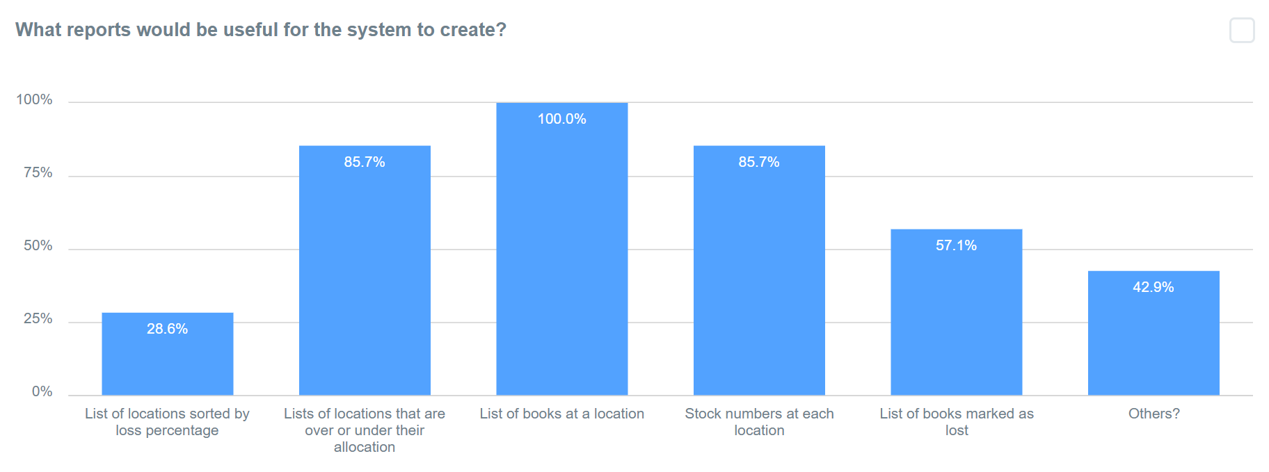

There was one report that every surveyee requested which was a list of books at a location. This would be useful for taking stock checks and returning books so that the school can be informed in advance which books need to be made available for the SLS library assistants to count.

The second most requested reports are a list of locations that are over or under their allocation and the stock numbers at each location. These reports could easily be combined into one with a list of schools, their current stock numbers, allocation amounts and whether they are over or under their allocation.

The third most requested feature was a list of books marked as lost. This would be useful for reordering lost books as well as finding out which schools are the worst at losing books so that the problem can be addressed.

The least requested report was a list of locations sorted by loss percentage. This would be used for identifying problem schools when it comes to losing books but, as shown in the survey, isn’t a high priority feature and similar functionality could be achieved with the list of lost books report, albeit less efficiently.

###### Fig 11. *Open responses to the question regarding the reports that the system should create.*

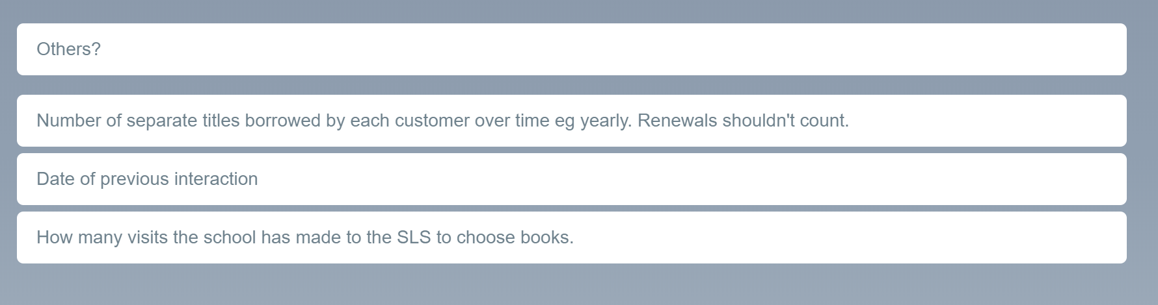

The survey also had an open response box on question regarding reports. Three surveyees put extra reports in this section.

The first suggested report was the number of unique titles borrowed by each school over a certain time frame. This could be useful for analysing whether a school typically takes many of the same books (indicated by a low number of unique titles) or whether they take one or two of many different titles (indicated by a high number of unique titles).

The second suggested report was a list of schools with the date of the previous interaction. This could be useful if a school didn’t book a new date for their next exchange and the SLS library assistants can then work out when their next exchange should take place and contact the school. To improve upon the suggest functionality of this report, a list of next exchange dates pulled from the calendar feature would allow the SLS library assistants to see whether the school has booked another exchange from the same window.

The third suggested report was how many visits the school has made to the SLS to choose books. This would be useful to analyse how often a certain school typically visits and then base the next visit from the average elapsed time between previous visits.

Of all these reports, there are three high priority reports based on amount of requests and observed importance based on the brief and then four low priority reports where only one or two requests were made or its additional functionality that could be built into one of the other reports at a later date.

The three high priority reports that will developed first before the first release version of the software is finalised are:

1. A List of Books at a Location
2. A List of Allocation Statistics regarding number of books at a location.
3. A List of Books Marked as Lost

The other reports that are considered useful would be developed after the initial release of the software as part of a functionality update.

###### Fig 12. Responses to the open question regarding what format the reports should be in.

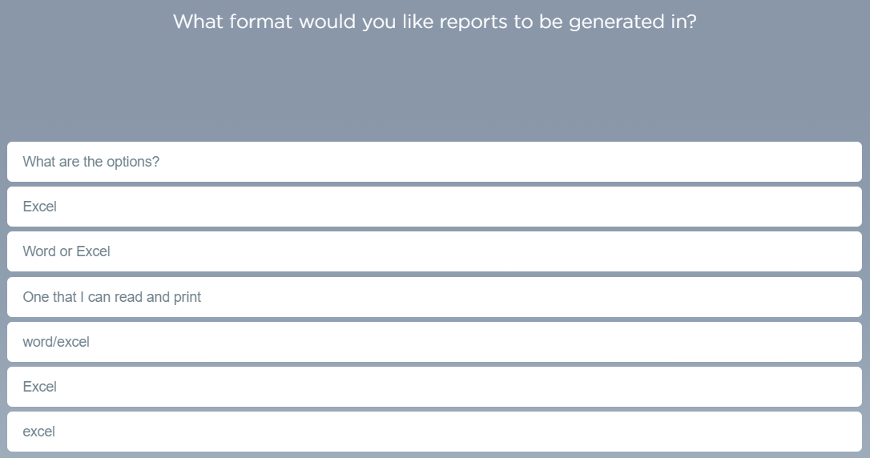

To determine the format that the reports should be created as, I put an open answer box with the question “What format would you like the reports to be generated in?” which resulted in the above responses. The general consensus was that a format from a standard office application would work best as the users already have those applications installed and available to them. It would also be beneficial to use an already existing standard for the reports as that wouldn’t require any additional training in order to open and print the reports. As for the final file type, the most requested format was an excel file. This file type also makes the most sense from a programming perspective as there is an easy to use and open-source library available for creating spreadsheets from the report data as stored in the code.

##### **Evaluation:**

This questionnaire has a few flaws in the way it was carried out. Firstly, the sample size (n=7) that completed the questionnaire was smaller than the already limited target population that is the SLS library assistants. This means that my responses are less likely to be varied or represent the views of library assistants from other services offered by other counties who could be interested in using the system.

#### 

#### **Identification of User Needs**

* Reports
  + A List of Books at a Location
  + A List of Allocation Statistics regarding number of books at a location.
  + A List of Books Marked as Lost
* Calendar
* no more than 2 of a certain title per school.
* format for reports

#### **Acceptable Limitations:**

* Only able to use it on one computer because the database is kept locally and does not support multiple concurrent database connections.

### **Data sources and destinations**

The first main data source for the program is the database in which most data will be stored. In the database there are five tables for the user logins, book details that have been modified, school details, loan information and what loan a book is on.

The second main data source for the program is the Google Books API. The API will allow the program to collect information about a book for various reasons. The most important feature for the user is that it can use the data from Google Books to generate a list of books that are currently checked out to a school so that the school can make sure they don't miss any books because they didn't know it was part of the SLS loan.

The data coming out of the program will be the lists of books at locations as well as reports on the loss rate and other statistics that can be calculated about the loans.

#### **Data Volumes**

The main data volume is the SQLite database backend of the program. It contains all of the data on books and loans as well as schools. The size of the database, once implemented in a production environment, will be much higher than the testing version because of the difference in quantities of books and schools which means I can't yet estimate the size of an implemented database.

Schools table: 3 digit integer for id, 40 characters for name, 210 characters for address, 70 characters for HT, 10 characters for date, 10 characters for DFE, 11 characters for contact, 2 digits for items per pupil and 4 digits for no of pupils adds to 360 characters per row which approximately equals 360 bytes per row. There are currently 85 schools in the test database based on a sample version of the current system from 6 or 7 years ago. So an estimated maximum number of schools could be upto about 200. Therefore for the schools table, there would be 72,000 bytes of data or about 72KB.

Login table: 2 digits for user id, 40 characters max for username, 128 characters for the sha512 password hash and 5 characters for admin or not, adds to 175 bytes per row. There would be about 10-20 users at the base location so assuming 20 users/rows with 175 bytes per row, the estimated maximum for this table is 3500 bytes or 3.5KB.

Loans table: 4 digits for loan id, 10 characters for the date of loan, 3 digits for school id and 5 characters for whether the loan is active or not, adds to 22 bytes per line. Each school visits approximately 3-6 times a year so assuming max 6 visits a year and max 200 schools, the total for the table would be 26.4KB per year.

Changed books: 13 characters for isbn, 100 characters for title, 50 characters for author, 30 characters for genre, 10 characters for release date, 4 characters for binding, 10 characters for age, 4 characters for label, 500 characters for blurb and 5KBs for the cover image adds to 5707 bytes per row. The users will choose how many books get modified but with an estimate of 200 books being modified, it would need 1.1MB.

Calendar table: 3 characters for event id, 3 characters for school id, 10 characters for date, 20 characters for event type, 500 characters for notes and 5 characters for time adds to 541 bytes per row. Assuming a max of 6 exchanges and 6 stock checks for each of a max of 200 schools per year, one year of events would be 1.3MBs.

Books table: 13 characters for isbn, 2 digits for copy number, 4 digits for loan id and 5 characters for lost or not, adds to 24 bytes per row. Assuming about 15,000 books in the system, it would total to 360MB.

The total size of all the tables after one year of active deployment would be about 362.5MB which would increase by about 1326KB each year.

### 

### **Objectives for Proposed System:**

#### Key Objectives:

1. The system must be able to sign books in and out to different schools.
2. The system should keep track of books in-stock and at different the schools.
3. The system should have a database to store details about the schools that subscribe to the service.
4. The system must be able to produce reports about the loan history of individual schools and the service as a whole.
5. The system should have a login policy to protect sensitive data about the subscribed schools.
6. The graphical user interface must be user friendly and intuitive.
7. The system should protect the database from SQL Injection attacks that could otherwise cause irreversible damage to the structure and contents of it.
8. The system should be able to look up the details of book from the internet or a database with modified details and use those details in various places.

#### Additional Objectives:

1. The system should use Object Oriented Programming where possible.
2. The system could have a settings menu where the user can customise their experience (e.g. colour themes) and change the locations of any required files.
3. The system could have a calendar system to manage school visits.
4. The systems reporting function could calculate various statistics about their visits, borrowing history and amount of lost/damaged books.
5. The system could have a lookup system for books pertaining to a particular topic with a way to check their location.
6. The system should be able to make use of a barcode scanner for faster signing in and out of books.
7. The system should be simple to setup and install on the target users computers.

#### 

### 

### **Analysis data dictionary and ERD**

###### Fig 13. Database ERD

#### 

#### **Data Dictionary**

|  |  |  |
| --- | --- | --- |
| **Table Name** | **Columns** | **Description** |
| books | isbn, copy_no, loan_id | Links a copy of a certain book isbn to a loan via it's loan id. |
| changed_books | isbn, title, author, genre, binding, age, label, blurb, image | Stores the details of a modified book. |
| loans | loan_id, date, school_id, active | Stores the details of a loan linking it to a school. |
| login | userID, username, password, admin | Stores the login details of users for to use when accessing the system. |
| schools | school_id, name, address, HT, lastEx, DFE, Contact, pupilTotal, itemsPer | Stores the details about a school. |

##### 

##### **Books**

|  |  |  |  |  |  |
| --- | --- | --- | --- | --- | --- |
| **Column** | **Required** | **Type** | **Field Length** | **Default Values** | **Notes** |
| isbn | ✔ | Text | 10 or 13 | -- |  |
| copy_no | ✔ | Integer | N/A | -- |  |
| loan_id |  | Integer | N/A | -- |  |

##### 

##### **changed_books**

|  |  |  |  |  |  |
| --- | --- | --- | --- | --- | --- |
| **Column** | **Required** | **Type** | **Field Length** | **Default Values** | **Notes** |
| isbn | ✔ | Text | N/A | -- |  |
| title |  | Integer | N/A | -- |  |
| author |  | Integer | N/A | -- |  |
| genre |  | Integer | N/A | -- |  |
| released |  | Integer | N/A | -- |  |
| binding |  | Integer | N/A | -- |  |
| age |  | Integer | N/A | -- |  |
| label |  | Integer | N/A | -- |  |
| blurb |  | Integer | N/A | -- |  |
| image |  | Blob | N/A | -- |  |

##### 

##### **loans**

|  |  |  |  |  |  |
| --- | --- | --- | --- | --- | --- |
| **Column** | **Required** | **Type** | **Field Length** | **Default Values** | **Notes** |
| loan_id | ✔ | Integer | N/A | -- | Auto-Increment |
| dates | ✔ | Text | N/A | -- |  |
| school_id | ✔ | Integer | N/A | -- |  |
| active | ✔ | Text | N/A | -- |  |

##### **logins**

|  |  |  |  |  |  |
| --- | --- | --- | --- | --- | --- |
| **Column** | **Required** | **Type** | **Field Length** | **Default Values** | **Notes** |
| userID | ✔ | Integer | N/A | -- |  |
| username | ✔ | Text | N/A | -- |  |
| password | ✔ | Text | 128 | -- |  |
| admin | ✔ | Text | N/A | -- |  |

##### 

##### **schools**

|  |  |  |  |  |  |
| --- | --- | --- | --- | --- | --- |
| **Column** | **Required** | **Type** | **Field Length** | **Default Values** | **Notes** |
| school_id | ✔ | Integer | N/A | -- | Auto-Increment |
| name |  | Text | N/A | -- |  |
| address |  | Text | N/A | -- |  |
| HT |  | Text | N/A | -- |  |
| lastEx |  | Text | N/A | -- |  |
| DFE |  | Text | N/A | -- |  |
| Contact |  | Text | N/A | -- |  |
| pupilTotal |  | Integer | N/A | 0 |  |
| itemsPer |  | Integer | N/A | 3 |  |

### 

### **Realistic appraisal of the feasibility of potential solutions:**

Key:

|  |  |
| --- | --- |
| **Character** | **Note** |
| 🗸 | Very difficult but still possible |
| ✓ | Possible but time consuming |
| ✔ | Yes |
| ❌ | No or not practical |

|  |  |  |  |  |  |  |  |  |
| --- | --- | --- | --- | --- | --- | --- | --- | --- |
| **Project Platform** | **Windows** | **MacOS** | **Linux** | **Android** | **iOS** | **Experienced with** | **Has libraries to use** | **Supports USB Scanners** |
| Python Text Interface | ✔ | ✔ | ✔ | ❌ | ❌ | ✔ | ✔ | ✔ |
| Python Tkinter GUI | ✔ | ✔ | ✔ | ✓ | 🗸 | ✔ | ✔ | ✓ (Bluetooth version required for Android and iOS) |
| Python Kivy GUI | ✔ | ✔ | ✔ | ✔ | ✔ | 🗸 | ✔ | ✓ (Bluetooth version required for Android and iOS) |
| Visual Basic | ✔ | ❌ | ❌ | ❌ | ❌ | ✔ | ❌ | ✔ |
| Java | ✔ | ✔ | ✔ | ✔ | ✔ | ❌ | ❌ | ✔ |
| WebApp | ✔ | ✔ | ✔ | ✔ | ✔ | ❌ | ✔ | ✓ (more setup required on user end + Bluetooth version for mobile) |

### **Justification of chosen solution:**

* Python with Tkinter GUI

I have chosen to use Python with Tkinter for the GUI as my method of choice for my project. I am using it because I know Python quite well (compared to Visual Basic which is the only other language I have used before) and I have already learnt Tkinter as a GUI implementation technique for Python as opposed to learning Kivy just for being able to easily put the program on mobile devices.

I also know that the users have Windows machines as their desk computers at the site meaning mobile devices are not a required feature.

## 

## **Design**

### **Overall System Design**

###### Fig 14. System Design Flowchart.

### 

### **Description of modular structure of system**

#### **Modules:**

All of the code has been separated into different python modules (*.py). These modules can be imported into other parts of the code to allow modularity in the structure of the program. The modules also reduce the amount of code needed to be written as they can imported to allow the calling of the functions inside the modules.

#### **Objects:**

Objects are callable by any other part of the code where the modules are imported.

Some objects that I have implemented include:

* Entry form object
* book details object
* Homepage object
* Multi Entry init form object
* Multi Entry form object
* settings menu object
* School Details View menu
* School Details Buttons menu
* Calendar object
* Calendar Event details object
* Reports menu object
* Settings menu object
* Add New User object

|  |  |  |  |  |
| --- | --- | --- | --- | --- |
| **Object:** | **Description:** | **Uses:** | **Called by:** | **Calls:** |
| Entry Form | For entering a single value to be processed. | Entering an ISBN to view the details of that book. | Homepage | Book Details |
| Book Details | Displays the title, author, etc. that is passed into the object. | Displaying the details of a book. | Entry Form | Homepage |
| Homepage | The main menu of the program. Has buttons to call each of the parts of the program. | Calling smaller independent parts of the program such as Settings and the Multi Entry form. | Starting the program, Book Details, Settings, Multi Entry, Entry Form. | Entry Form, Multi Entry, Settings Menu |
| Multi Entry Init | For choosing a school to sign books in from or out to. | Configures the multi entry page to the correct school and correct method. | Homepage | Multi Entry |
| Multi Entry | For entering multiple values to be processed. | Entering many ISBNs to be assigned to a loan. | Multi Entry Init | Homepage |
| Settings Menu | Changing settings that apply globally to the program. | Changing the colour theme of the program. | Homepage | Homepage |
| School Details View | For the viewing, editing or creating of school profiles in the database. | Can be used to create a new school profile in the database, edit a pre-existing one or viewing the details of one. | School Details Init. | Homepage. |
| School Details Init | Initialising the school details view object. | Opens the School Details View in new school mode for creating a new school or selecting an existing school | Homepage. | School Details View. |
| Calendar Object | Viewing, editing and creating events in a typical calendar format | Has an interactive calendar with which the user can change the month and year to view the corresponding events and can also create events using a button and the resulting popup and edit the events with double clicking on the event name on the calendar. | Homepage | Homepage. |
| Reports | Interface for generating reports based on data from the system | Has a series of dropdown menus that the user can use to select a report type and any required options for it to be generated. The button to generate a report will appear once all the required options have been selected. Once clicked it will trawl the database for the data needed by the report and create a table in a new window with the report. Once generated, there is an option to print the report as a Excel spreadsheet that can be sent to schools or fellow library assistants, or can be used to print the report onto paper. |  |  |
| Settings | Modify settings pertaining to the functionality and aesthetics of the program. | This menu allows the user to change settings stored in a json file through a user friendly interface. It has fields for the database location and the root folder with buttons to bring up the standard windows file/folder selection window. It also has a drop down menu to select the theme for the colours of the system. If the user is an admin, a button for adding a new user appears alongside the other settings. | Homepage | Homepage, Add New User |
| Add New User | Create the credentials for a new user to login to the system. | This menu allows an admin to create a new login profile for a user to access the system with. | Settings | Settings |
|  |  |  |  |  |

#### **Function Modules**

Some of the modules written only contain functions and algorithms that other parts of the program can import and use.

The function modules that I have written are:

* books_api
* gui
* img2gif
* misc_python
* sql

The "books_api" module is for interacting with and processing the data from the Google Books API. It contains three functions.

The first function takes an ISBN from the program and returns properly formatted python dictionary with all of the details about the book.

The second function is used to get a specific detail about a book from the dictionary returned by the first function.

The third one runs the second function for all of the details required in the book details window and returns them in a format that can be accepted by the book details object for being displayed or compared against the modified data from that window.

The "gui" module is written to make bringing up a new window easier.

Each function in the module contains the few lines of code required to call a new GUI object so that other parts of the program can do so in one line. It also makes the program code easier to read since the same lines of code are repeated less often.

The "img2gif" module is for the manipulation of the book cover images before they get displayed in the Book Details window.

The tkinter canvas object on the window only accepts image files in the GIF type whereas the Google Books API stores all of the images as JPEG files. This means in order to display them correctly, the program needs a way to convert between the different file types.

As well as the file type discrepancy, there are often differences between the resolution of the image file from the Google Books API and the tkinter canvas object in which the images are needed to be displayed. This module also solves that issue by resizing the images to the correct resolution to reduce the blank space around the image and to keep as much of the cover from being cropped.

The "misc_python" module is different to the other function modules in the fact that it wasn't written specifically for this program. Instead, it is a collection of useful functions and algorithms that I have written and collated into one module for use in any program I write.

One example of a function it contains is a binary search algorithm for searching through lists for a specific item.

Another function is a sorting algorithm which sorts alphabetically and numerically to make sure that multiple digit numbers are sorted correctly and not by the first digit as happens with algorithms like quicksort.

The last function module I've written is a module for interacting with the sqlite database that the program is based around. This module is made up of lots of functions, each with its own SQL query, that can be executed in a connection to the database using variables that are passed into the function from the main program.

#### **Modular Design**

* Login Screen
  + Login Button
    - Main Menu Screen
      * Book Details
        + Single Entry

Submit

Book Details (Title, Author etc of the book specified by isbn)

Save Changes

Close

Revert to online data

* + - * Sign Out Books
        + Destination Select Screen

Sign In

Multi-Entry

Sign In

Sign Out

Multi-Entry

Sign Out

* + - * School Details
        + School Selection Screen

Edit School

School Details (Edit Mode)

New School

School Details (New Mode)

View School

School Details (View Mode)

* + - * Settings
        + Settings

Theme Select

Database Location

Root Folder

Add New User (Only when admin)

Add New User

Close

* + - * Log Off
      * Quit Program

### **Definition of data requirements**

### **Identification of appropriate storage media**

### **Entity relationship diagram(Normalised)**

#### **Entity Relationship Diagram:**

###### Fig 15. Program Entity Relationship Diagram.

### **User interface design (HC)**

#### **Login Screen**

###### Fig 16. Login screen.

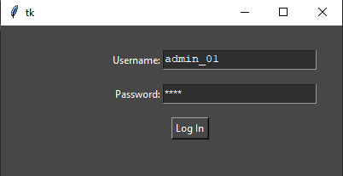

This is the Login screen that is presented when the user opens the application or logs out from the homepage. The menu is characterised by a pair of entry fields, one for the username and one for the password, as well a submit button. The button isn't the only way to run the authentication process as the user can also press Enter to submit the details as is standard of most login systems. The password field is obscured upon entry with asterisks (*) replacing each character as is standard with almost all Windows-based login systems as well as on many websites. When submitted, the password is hashed with an SHA512 cryptographic hash function before being compared with the hashed password associated with the given username that is stored in the databases login's table.

#### 

#### **Homepage**

###### Fig 17. Program Homepage.**Homepage**

This is the homepage for the application where the user can navigate to all of the various parts. The homepage is made up of various buttons linked to the different sections of the program. There are also buttons for Log Off and Quit to allow the user to end their unique session or to completely close the application respectively. At the top of the window is the program name and logo and at the bottom is a welcome back message with the current username.

#### **Book Details**

###### Fig 18. Entry form for single ISBN.

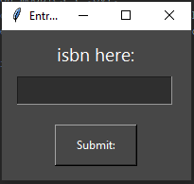

This part of the book details process is for taking the inputted ISBN for a book and passing it through to the next section. The menu has a entry box for the ISBN and a label above it to instruct the user on what to input. Below the entry box is a button which will submit the contents of the entry box to the next bit of the Book Details section.

###### Fig 19. Book Details formBook Details

This is the window that is used to display the details of a book. The details are pulled from either the sqlite database (if there is an entry for that), ISBN or the Google Books API if there isn't. The details that are available for being displayed are:

* Title (and subtitle if applicable)
* Author(s)
* Genre
* Release/Publish Date
* Age Rating
* Blurb
* Cover Image

This also includes two placeholder fields for anything else requested by the end users. At the bottom of the window are three buttons. One of these will save any changes made to the details by the user to the sqlite database. The next one will close this part of the program and return to the homepage of the application. The last button will delete any entry in the database and allow the program to use the original Google Books data for the details.

#### **School Details**

###### Fig 20. Menu for selecting the a school to show the details of.**School Selection**

This window is for selecting a school to view or edit the details of or to add a new school to the system. There are three buttons on the left of the window:

* New School for creating a profile of a new school in the database
* View School for viewing the details of an existing school profile
* Edit School for editing the details of an existing school profile

On the right of the window is drop down menu containing the list of existing school profiles to select from for use in the View School or Edit School windows.

The School Details main window has three variants which are chosen in the previous window. All of the variants are have the same fields to fill in or be viewed but they start differently depending on the variant. The fields are:

* School Name
* Head Teacher
* Last Exchange
* Contact:
* DFE No'
* No' of Pupils
* Allocation per pupil
* Total Allocation
* Address There is also a button next to the address field which will open Google Maps with the location of the school in the default web browser. At the bottom of all of the variants is a button to close the details menu and return to the homepage.

###### Fig 21. Empty School Details form for adding a new school.

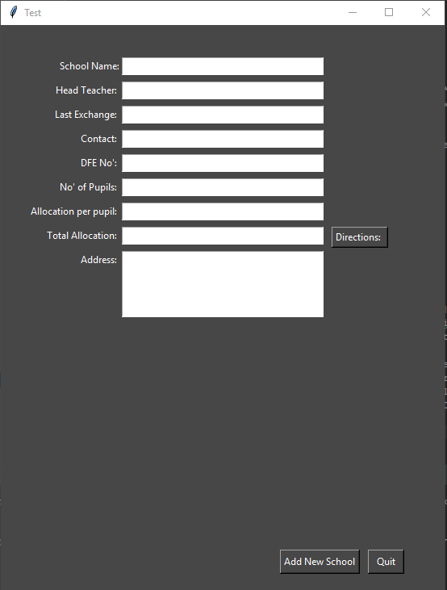

The first variant of the School Details window is for create a new profile for a school. It has the same fields as the other variants but all are left blank for the user to fill in. At the bottom of the field is an Add New School button to save the entered details to the database as a new school.

###### Fig 22. School Details form in view mode with no save button for any changes.View School

The second variant does not have editable field for the school name or a button to save changes as it is only for viewing the details of a chosen school.

###### Fig 23. School Details form filled out with values from the database.Edit School

The third and final variant is for changing the details of a school. As such, it starts with all of the details fields filled with the details in the database ready for being changed by the user and has a Save Changes button at the bottom for committing any changes to the database.

#### 

#### **Sign Out Books**

###### Fig 24. Menu for initialising the loaning and return process.

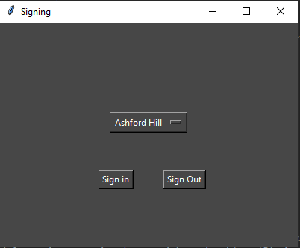

This window is for selecting a school to sign books out to or in from. It has a list of the schools in the system in a drop down menu to select one and two buttons to choose whether you're signing books in or out with respect to that location.

###### Fig 25. Empty Loaning/Returning formMulti-Entry Main

This window has a single entry box for entering an ISBN of a book. The user enters the ISBN and presses the Enter key. This puts the ISBN in the list box on the left and collects the title from the database or the Google Books API and puts it in the list on the right to help make sure the correct book has been entered. Once all of the ISBNs are entered, the user clicks on the Sign In/Sign Out button which will sign the books out to the location selected in the previous window.

#### 

#### **Settings**

###### Fig 26. Settings menu as seen when signed in as an admin.**Settings**

This window is where the user can change any settings pertaining to the application that might need to be modified. The first setting is the application-wide theme option. This is changed via a drop down menu with a list of the available themes that can be chosen from. The next setting is the location of the sqlite database. This is chosen via a file path to the database file which can be selected via the Windows Open File dialog. The next setting is the root folder location for the program to use as a file location for the temporary storage of cover images for books and long term storage of icons required for the program. The last setting is an Add New User button for creating a new user profile which can be used on the login screen to access the application. This setting is only available to accounts with administrator privileges.

### 

### **Hardware specification**

#### **Input Devices**

Currently Required: Keyboard, Mouse. Optional: Barcode Scanner (untested)

* Keyboard: allows manual entry of barcodes and editing of book details.
* Mouse: for interaction with buttons on the forms. (tab is untested.)
* Barcode scanner: easier input of isbns stored as barcodes on most books.

#### **Output Devices**

Required: Monitor.

* Monitor: viewing of GUI.

#### **Storage devices**

Required: Program files and sqlite database. unknown sizes as unfinished. database may be moved to a server.

#### **Processor and Memory requirements**

By using Python to create the program, I have been able to keep the program quite lightweight in terms of system resources needed to run it.

#### **Table:**

|  |  |  |  |  |  |  |
| --- | --- | --- | --- | --- | --- | --- |
|  | **Processors** | **Memory** | **Storage** | **OS** | **Screen Resolution** | **Peripherals** |
| Minimum: | i5-520M | 6GB SODIMM DDR3 | 80.1MB w/out third-party modules | Win7 32bit |  | Keyboard and Mouse |
| Recommended: | Ryzen 7 1800x | 16GB DDR4 | 8GB with all required modules | Win10 64bit | 1920x1080@60Hz | Barcode Scanner |
| Also Working: | i5-4460 | 8GB DIMM DDR3 |  |  | 1920x1080@60Hz |  |

## **Testing**

### **Description of measures planned for security and integrity of data and system security**

* sql injection prevention

### **Overall test strategy**

* test for sql injection
* see if it breaks under normal use cases
* test under extreme use cases to see if it breaks

Once I have finished creating the program, I will test it in a few main areas. Firstly, I will test against the key objectives to check that required functionality is working. This is done by attempting to complete a task that fits with the key objective being tested, for example signing books out to or in from a school to test Key Objective I.

Secondly, I will stress test the parts of the system where the length of the process varies based on amount data entered or stored in the database by using larger amounts of data than is realistic in typical use of the system, for example, excessively large numbers of books being loaned in one transaction (the library have a recommendation of about 200 books per exchange so 400 books in one go should be enough to stress the system).

### 

### **Testing Details**

###### Fig 27. Table of Tests conducted.

## 

## **System Maintenance**

### **System Overview**

When the system is opened by the user, they are greeted with a log on form. This log on form is setup using entry boxes to collect the users login credentials to allow the user to log on and access the system. The user will type in their log on credentials and press the Enter key or click the Log In button on the form. If the credentials match any of the stored credentials in the database, the user will be taken to the system homepage.

The system homepage is the way the user accesses the other parts of the system from one central form. It has buttons for the user to press to take them to the various other parts. One of the other parts is a way to look up the details of a book by it's isbn. The user enters the isbn into a form that appears when the Book Details button on the homepage which then passes it through to the details form. The details form displays the books title, authors, genre, release/published date, age rating, blurb and cover image.

Another section is the part for loaning books out to schools and returning them to the base location. The first part of this sub-system is a form to select the school that is having books exchanged with using a drop-down menu and a pair of buttons either Sign Out books to that school or Sign In books from that school. The second part of the sub-system is a form for entering the ISBNS that are part of the exchange. The isbns are entered into a entry box and stored visually in a listbox with the corresponding titles in another list box next to it. Once the ISBN have been entered and the submit button has been pressed, the system processes all the books and adds them to the a new loan in the database for signing out books or to the existing loan for returning them to the base.

Another section is the part for retrieving data about a school in the database. The first part of this sub-system is a form for selecting the school from a drop-down menu and three buttons to select which mode the second form should open in, whether the user is viewing or editing a school or adding a new school into the system.

Another section is the method for generating reports based on the data in the database. Through the use of a set of drop down menus to select the report type and any other parameters for the report, the user can generate one of a few reports pertaining to the service.

Another section is the calendar part of the program. This is for managing events such as stock checks and exchanges through the system. It is made of a simple, normal calendar layout to view a months worth of events at once and dropdown menus to select the month and year. Double clicking on an event in the calendar will bring up a detailed view of the events including all the details stored along with notes about the event.

The last section of the system is a settings menu for making changes to the functionality of the system including file locations for icons and the database file, and the aesthetic theme of the program. If the user is logged in as an administrator then an option to add a new user to the system is also present as a button to bring up the relevant form.

### **Sampled Detailed Algorithms**

## 

## **Guide**

#### Accessing the System via the Login Menu:

1. Start the program.
2. Select the **Username** field (Fig 28, Ref **➀**) with the mouse or the *Tab* key.
3. Enter the username for the system.
4. Either using the *Tab* key on the keyboard or the mouse to navigate to the **Password** field (Fig 28, Ref **➁**).
5. Enter the password associated with that username. As a hint, in case the password has been forgotten, the password requirements are at least one of each of the following:
   1. Uppercase Characters.
   2. Lowercase Characters.
   3. Numbers.
   4. Special Characters.
6. Press the *Enter* key on the keyboard or click the **Log In** button (Fig 28, Ref **➂**) with the mouse to attempt an authentication.
7. If the username and password are correct, the user will be taken to the programs **Homepage** (Fig 29.)*.* If not, an error box will appear saying that the authentication failed and that the user should try again.

###### Fig 28. Login menu with references for user guide.

#### Homepage:

Once signed in, the user will be brought to the homepage of the program. From this page, they can access the various parts of the system through the use of clearly labeled buttons. Each main function of the program has its own button including:

* **Book Details** (Fig 29, Ref **➀**)
* **Loaning/Returning Books** (Fig 29, Ref **②**)
* **Reports** (Fig 29, Ref **③**)
* **School Details** (Fig 29, Ref **④**)
* **Calendar** (Fig 29, Ref **⑤**)
* **Settings** (Fig 29, Ref **⑥**)
* **Log Ou**t (Fig 29, Ref **⑦**)
* **Quit** (Fig 29, Ref **⑧**)

**Log out** (Fig 29, Ref **⑦**) will return the user to the login menu so the system is secure in the case of unauthorised people with physical access to an unlocked computer in the library.

**Quit** (Fig 29, Ref **⑧**) will close the program completely and return the user to the desktop.

###### Fig 29. Homepage screenshot with references for user guide.

#### Viewing and Editing Book Details:

The first button on the homepage is labelled Book Details. This feature is for looking up the details of a book by its ISBN.

1. Click the **Book Details** button (Fig 29, Ref **➀**) on the Homepage.
2. Enter the ISBN either with a Barcode Scanner or typing it into the entry field (Fig 30, Ref **➀**) and pressing the **Enter** key or the **Submit** button (Fig 30, Ref **②**).
3. The system will now produce the following details about the book.
   1. Title (Fig 31, Ref **①**)
   2. Author (Fig 31, Ref **②**)
   3. Genre (Fig 31, Ref **③**)
   4. Release Date (Fig 31, Ref **④**)
   5. Age Rating (Fig 31, Ref **⑥**)
   6. Blurb (Fig 31, Ref **⑧**)
   7. Cover Image (Fig 31, Ref **⑨**)
4. The details are currently displayed inside Entry fields which the user can edit. Using these, the user may correct errors or add missing details for that book.
   1. To save any changes that have been made, click the **Save Changes** button (Fig 31, Ref **⑩**) to commit the modifications to the database. These saved details will be prioritised over data from the internet when the system needs any data about the book.
   2. If the user changes their mind about saved modifications, clicking the **Revert to Online Data** button (Fig 31, Ref **⑫**) will delete any details about the current book from the database allowing the system to use the data from the Google Books API.
5. Once finished in the window, clicking the **Close** button (Fig 31, Ref **⑪**) will return the user to the programs Homepage.

###### Fig 30. ISBN Entry form.

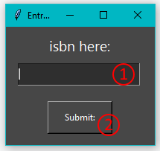

###### Fig 31. Book Details form.

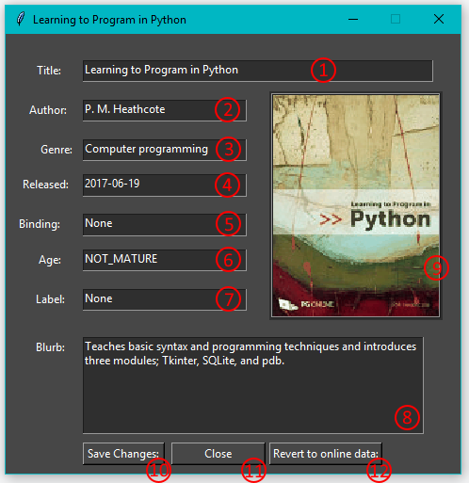

#### 

#### Loan Books out to a School

1. Click the **Sign Out Books** button (Fig 29, Ref **②**) on the Homepage.
2. Select the school from the drop down menu (Fig 32, Ref **①**) .
3. Click the **Sign Out** button (Fig 32, Ref **③**)

###### Fig 32. Loaning starting menu.

1. Select the **ISBN entry** field (Fig 33, Ref **③**)
2. Enter the ISBN:
   1. If using a keyboard, type it in and press the Enter key
   2. If using a barcode scanner, scan the barcode.
3. The ISBN that has been entered will appear in the List Box on the left (Fig 33, Ref **①**) and the book title will appear in the List Box on the right (Fig 33, Ref **②**).
4. Repeat **Step 5** until all the books have been entered.
5. To confirm the loan, click the **Sign Out** button (Fig 33, Ref **③**).

###### Fig 33. Multiple Books entry form.

#### 

#### Return Books from a School

1. Click the **Sign Out Books** button (Fig 29, Ref **②**) on the Homepage.
2. Select the school from the drop down menu (Fig 32, Ref **①**) .
3. Click the **Sign In** button (Fig 32, Ref **②**)
4. Select the **ISBN entry** field (Fig 33, Ref **③**)
5. Enter the ISBN:
   1. If using a keyboard, type it in and press the Enter key
   2. If using a barcode scanner, scan the barcode.
6. The ISBN that has been entered will appear in the List Box on the left (Fig 33, Ref **①**) and the book title will appear in the List Box on the right (Fig 33, Ref **②**).
7. Repeat **Step 5** until all the books have been entered.
8. To confirm the loan, click the **Sign In** button (Fig 33, Ref **③**).

#### Generating Reports:

One of the features provided by the program is a process for generating reports of useful data based on statistics from the system.

1. Select the report wanted from the **drop down menu**  (Fig 34, Ref **①**) at the top of the form.
2. If the selected report needs a location to gather data about, select that from the **second drop down** menu (Fig 34, Ref **②**) that has appeared.
3. Once all the drop down menus have been filled out, the **Generate** button (Fig 34, Ref **③**) will appear at the bottom. Click the button to generate a report in the form of a table in a new window.
4. On the window with the report table there is a button labelled **Print**  (Fig 35, Ref **①**) . This button will convert the report in the window into an Excel spreadsheet saved into a folder in the users documents folder. With the spreadsheet version, you can send it to anyone who needs it (ie a list of books at a school can be sent to the school in question) or it can be printed out onto paper for filing or taking to a location.

###### Fig 34. Reports Wizard

###### 

###### Fig 35. Example of a generated Report.

#### Adding, Editing and Viewing School Details.

One of the buttons on the homepage is for viewing the details about a school that is subscribed to the SLS service.

The details include:

* School Name (Fig 37 a/b/c, Ref **①**)
* Headteachers name (Fig 37 a/b/c, Ref **②**)
* Date of last exchange (Fig 37 a/b/c, Ref **③**)
* Phone Number (Fig 37 a/b/c, Ref **④**)
* Department for Education number (Fig 37 a/b/c, Ref **⑤**)
* Number of pupils at the school (Fig 37 a/b/c, Ref **⑥**)
* Number books allowed per pupil (Fig 37 a/b/c, Ref **⑦**)
* Number of books allowed total (Fig 37 a/b/c, Ref **⑧**)
* Address (Fig 37 a/b/c, Ref **⑨**)

1. Click the **School Details** button on the homepage.
2. Select the school from the **drop down menu** (Fig 36, Ref **④**).
3. Using the buttons on the form, choose whether you are viewing the details (**View School,** Fig 36, Ref **②**), changing the details (**Edit School,** Fig 36, Ref **③**) or adding a new school to the system (**New School,** Fig 36, Ref **①**).

###### Fig 36. School Details form.

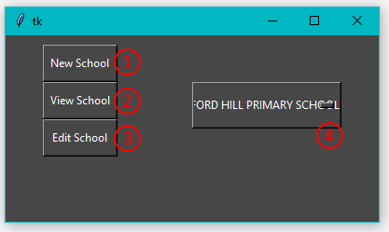

* 1. **Viewing the details.** On this screen (Fig 36 a) there will be no option to save so do not make any changes to the details here. A **Directions** button (Fig 37a. Ref **⑩**) is available next to the address field to get directions to the address in that box. This button will open up a new tab in the default browser with the Google Maps page for that address.

###### Fig 37 a. Viewing School Details

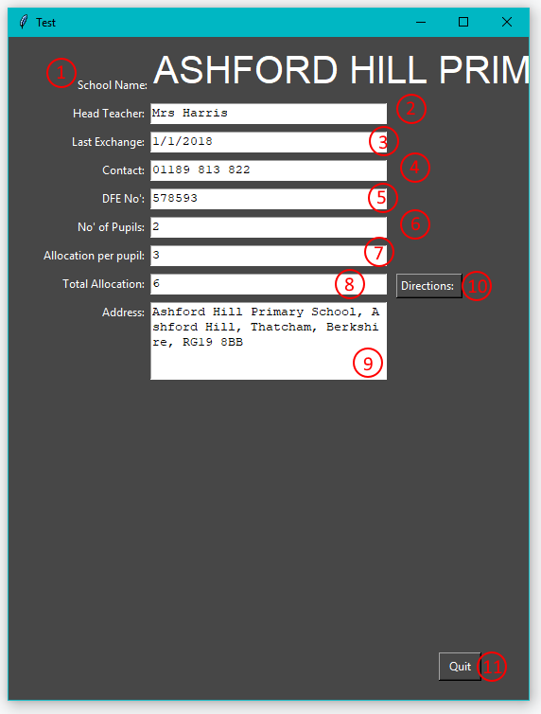

* 1. **Modifying the details.** On this screen (Fig 36 b), there will be **entry fields** (Fig 37b. Refs **①-⑨**) pre-filled out with the details of the school selected in the previous form.
     1. To change them, simply click on the field and change the contents using the keyboard.
     2. Once done, press save at the bottom to commit those changes to the database.

###### Fig 37 b. Editing School Details

* 1. **Adding a New School.** On this screen (Fig 36 c), the **entry fields** (Fig 37c. Refs **①-⑨**) will all be empty.
     1. To add the details, click on each **entry field** and type in the corresponding value.
     2. Once done, press the **Add New School** button (Fig 37c. Refs **⑪**) at the bottom to commit the changes to the database.

###### Fig 37 c. Adding a new school.

#### Settings:

Fig 38. Settings Menu

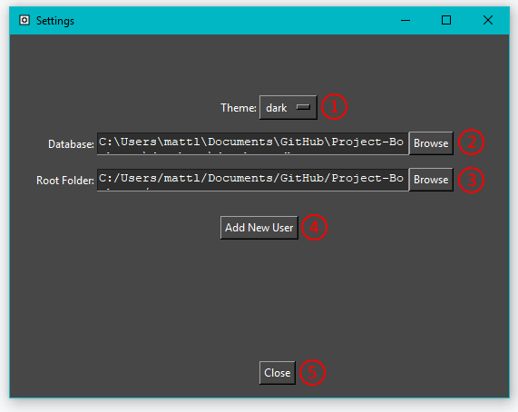

##### Changing the program theme:

1. Login to the system with any user.
2. Click the **Settings** button on the homepage.
3. Using the **drop down menu** (Fig 38, Ref **①**) at the top, select the new theme.
4. To apply the theme, click the **Close** button (Fig 38, Ref **⑤**) at the bottom of the menu.
5. You will be returned to the Homepage with the new theme having been applied.

##### Changing the Database Location:

1. Login to the system with any user.
2. Click the **Settings** button on the homepage.
3. Click the **Browse** button (Fig 38, Ref **②**) next to the Database entry field.
4. Using the file browser, select the database file.
5. Click the **Close** button (Fig 38, Ref **⑤**).

##### Changing the Assets and Temporary Files Location:

1. Login to the system with any user.
2. Click the **Settings** button on the homepage.
3. Click the **Browse** button (Fig 38, Ref **③**) next to the **Root Folder** entry field.
4. Using the file browser, select the database file.
5. Click the **Close** button (Fig 38, Ref **⑤**).

##### Adding a New User:

1. Sign in to the system as an Admin user.
2. Click the **Settings** button on the Homepage.
3. Click the **Add New User** button (Fig 38, Ref **④**) (note: this will only be available if the user is signed in as an administrator)
4. Fill out the required details
   * Username (Fig 39, Ref **①**)
   * Password (Fig 39, Ref **②**)
   * Password Confirmation (Fig 39, Ref **③**)
   * Admin Rights check box (Fig 39, Ref **④**)
   * Admin Password (Fig 39, Ref **⑤**)
5. Click submit. If any of the details don’t match the requirements, an error message will appear instructing you on what needs to be changed to correct it.
6. Once successfully submitted, a message box confirming the setup is complete will appear.
7. Check that the new user has been created successfully by:
   * Closing the settings menu
   * Logging out of the program using the **Log Out** button on the Homepage.
   * Log back in using the new user credentials.

###### Fig 39. Add New User menu

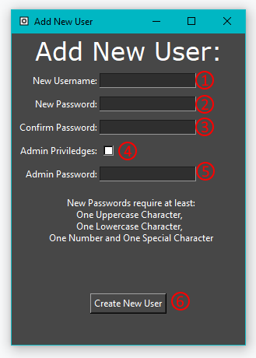

## **Evaluation**

#### Key Objectives:

1. The system must be able to sign books in and out to different schools.

I successfully managed to implement this feature into my program. There is a dedicated button on the Homepage to start the process of loaning or returning books to and from schools. The loans are created in the database and the books are tied to the loans.

The part of this Objective that I could have improved upon is the menu for entering the books to exchange. This form is rather rough around the edges with a lack of labelling regarding the input box and lists. With more time, I could have improved this by adding labels to describe the different UI elements which would make the form more intuitive.

1. The system should keep track of books in-stock and at different the schools.

I managed to include this feature in the program however the system doesn’t know what copy of a book is being processed, only that it is one of the copies at the start location in whatever process is being performed.

I could have improved on this by having unique barcodes for each copies on the books so that system can track the location of each actual book instead of just how many copies are at a location.

On the other hand, doing it by number of copies is fine since it is easier to code and reduces the work required in order to use the system as the SLS library assistants don’t have to print a unique barcode for each book they have.

1. The system should have a database to store details about the schools that subscribe to the service.

I successfully achieved this objective by storing all of the data in the system in a relational SQLite database. By using table relationships, I have removed duplicate data with everything normalised.

One way I could have improved on this objective is by hosting the database on a server. This would allow me to create the program in a way that multiple users could process exchanges of different machines at the same time improving the efficiency of the library.

However, since the SLS library assistants rarely have multiple schools visiting for exchanges at the same time, this feature isn’t as necessary as the main functionality and won’t hinder the processing of exchanges to a significant extent.

1. The system must be able to produce reports about the loan history of individual schools and the service as a whole.

I successfully created most of the reports that the sample users requested in the questionnaire. With more time available for development, I could improve on this by completing all of the reports. But since the most important ones have been completed, it would be acceptable for an initial version of the system to be missing some of the less vital reports.

1. The system should have a login policy to protect sensitive data about the subscribed schools.

I successfully implemented a secure login procedure upon launch of the program. The passwords are securely hashed in the database and associated with the username so the system can verify the users login without the passwords being visible to anyone who can view the database file in a separate program. However, the user id of the last person to log in is stored in the plain text settings file so that the program can work out whether or not they are admin but this is a small flaw since someone could manually edit it to be a user id with admin rights.

1. The graphical user interface must be user friendly and intuitive.

I believe I have met this objective by using large buttons with simple yet descriptive labels which should make the use of these buttons clear for users to follow in the use of the system. If the user does become confused, I have written a straightforward step-by-step guide on the various functions of the system.

To improve on the intuitiveness of the system, I could spend more time with someone who would use the system to make the design clearer to the target users.

1. The system should protect the database from SQL Injection attacks that could otherwise cause irreversible damage to the structure and contents of it.

This feature is currently untested but based on the way the SQL database queries were set up with the user input, it should automatically escape any malicious queries that have been attempted to be entered into the system.

1. The system should be able to look up the details of book from the internet or a database with modified details and use those details in various places.

I successfully achieved the first half of this objective (looking up details on the internet) by using the Google Books API to access the data about the books in the system. By using an API key and the Python Requests module, I am able to search for the details by ISBN.

The second objective was achieved by saving book details if that have been modified by the user. By only saving the changed details, I am able to reduce the size of the database by a significant amount.

In order to improve on this objective, I could have spent more time on the algorithm that parses the data from the Google Books API to verify the correct details are being used as, occasionally when the Google Books API returns the wrong book as the first one in the search results, the wrong book details are being used. Another way I could improve is to add a method to save the image of the book cover in the database so that it doesn’t have to resort to the error image.

#### Additional Objectives:

1. The system should use Object Oriented Programming where possible.

I have successfully achieved this objective as every window and form in the program is coded as a Class object which matches the idea of Object Oriented Programming.

1. The system could have a settings menu where the user can customise their experience (e.g. colour themes) and change the locations of any required files.

This objective was successfully achieved with a simple settings menu using drop down menus, wizards and standard file selection menus that are used by any Windows program that need to select a file which the users should be used to from other applications.

To improve, I could make some of the more important settings, like database file location, administrator only settings so the everyday users can’t interrupt functionality by accidentally changing an important setting.

1. The system could have a calendar system to manage school visits.

I have mostly completed this objective by making a Calendar that can show events on the correct day in the month and change the events and dates to match the selected month and year.

The way I could improve upon it is to add a create an event button to the calendar window to allow the users to book in dates for exchanges and site visits.

1. The systems reporting function could calculate various statistics about their visits, borrowing history and amount of lost/damaged books.

This objective was mostly achieved with one statistic report about the current allocation numbers which can be generated through the reports menu.

I could improve on this by making more report types able to be generated in the reports menu.

1. The system could have a lookup system for books pertaining to a particular topic with a way to check their location.

This objective was not achieved in the development of the system. This was because the nature of the objective is such that the system need an understanding of the topics of all of the books in the system which, in the timeframe of development, was un-achievable.

1. The system should be able to make use of a barcode scanner for faster signing in and out of books.

This objective was successfully achieved. All of the entry fields where ISBNs need entering are able to make use of a standard barcode scanner. This is important for the functionality of the system as it dramatically reduces the time it takes to loan out and return large numbers of books compared to having to type them in manually.

1. The system should be simple to setup and install on the target users computers.

This objective was unable to be achieved. In the time frame of development, researching and implementing both executable files and installers was time-consuming with inconsistent results on the execution of the compiled files.

Overall, I think I was able to achieve more than just enough of the key and additional objectives defined in the Objectives for the Proposed System however there are a few ways I could improve upon but these were mostly down to a lack of effective time management in the development process.

## **Program Code**

See folder attached. The file to run is the login.py module.